Logo here

**FIRE SAFETY PLAN**

**Dated:**

|  |  |  |  |  |  |
| --- | --- | --- | --- | --- | --- |
| **Document History** | | | | | |
| **Rev. No.** | **Date** | **Prepared** | **Reviewed** | **Approved** | **Revision History** |
| 01 |  |  |  |  |  |
|  |  |  |  |  |  |
|  |  |  |  |  |  |
|  |  |  |  |  |  |
|  |  |  |  |  |  |

|  |  |  |  |
| --- | --- | --- | --- |
| **Document Signatory** | | | |
| **Date** | **Name** | **Appointment** | **Signature** |
|  |  |  |  |
|  |  |  |  |
|  |  |  |  |
|  |  |  |  |
|  |  |  |  |

**Table of Content**

**Fire Safety Plan**

1 Purpose 4

2 Project Description 4

3 Scope 5

4 Definitions 5

5 Reference documents 5

6 Responsibilities 6

7 General 8

8 Fire prevention and fire protection 8

9 Fire evacuation 11

10 Inspection, maintenance and testing 11

11 Records 11

12 List of Drawings 12

13 Purpose 14

**Fire Equipment Maintenance Plan**

14 Scope 14

15 Definitions 14

16 Reference documents 14

17 Responsibilities 14

18 Department Heads 15

19 Requirements 16

20 Records 18

**Fire Evacuation Procedure**

21 Purpose 20

22 Scope 20

23 Definitions 20

24 Reference documents 20

25 Responsibilities 20

26 General information 22

27 Emergency procedures 23

28 Fire drills 26

29 Casualty management 27

30 Building schematics 27

**Appendices**

Project HSE Induction 29

Smoking Policy 100

Inventory of hazardous materials (HAZMAT) 101

Construction program - 3 Plan Dates 102

Hot Work Permit 115

Fire Pump Test 118

Daily Fire Inspection Checklist 122

Fire Extinguisher Monthly Inspection Register 124

Monthly Fire Alarm Test 126

Emergency Contact Detail 128

Fire Emergency Organisation 132

Emergency Drill Report 134

Drawings 66

# 

# Purpose

## This fire safety plan is to detail the emergency requirements at the <COMPANY NAME HERE> construction site.

# Project Description

<Write Description Here>

# Scope

## This plan is applicable to all occupants, visitors and contractors of the <COMPANY NAME HERE> construction site.

# Definitions

ECC : Emergency Command Centre

FFE : Fire Fighting Equipment

FPPM : Fire Prevention Program Manager

TG : Technical Guidelines

# Reference documents

# Responsibilities

## <COMPANY NAME HERE>

### Ensuring compliance with the requirements of the legislation.

### Ensuring that fire detection and suppression equipment is provided, maintained and kept in effective working order. Appointing a competent contractor to maintain and inspect fire notification and suppression equipment.

### Ensuring an appropriate fire risk assessment has been completed by a competent person for the premises and surrounding <COMPANY NAME HERE> sites.

## Project Senior HSE Manager (as Fire Prevention Program Manager)

### Act as the focal point in the emergency command centre during times of fire emergency.

### Coordinate the fire emergency organisation and liaise with the Civil Defense, police and ambulance service as required.

### Ensure deficiencies/discrepancies raised during fire inspections are rectified.

### Ensuring personnel are accounted for, noting of missing persons and reporting anomalies to the Civil Defence.

### Request mutual support from other projects located within the vicinity as required (e.g. Parsons, Galleria).

### Maintaining the fire safety inspection requirements records.

## Department Heads and Zone Construction Managers

### Action all reports of fire safety issues and defective fire equipment.

### Ensure there is at least one trained Fire Warden available at all times.

### Acting as the Emergency coordinator during times of emergency and ensuring the availability of a deputy in their absence.

## Fire Warden (HSE Engineers or Inspectors)

### Ensure that entrances, staircases and fire escapes are kept free of obstruction, are cleaned with trash removed on a daily basis or immediately if required.

### Inspect the construction site on a weekly basis to ensure the following:

* Fire extinguishers are in place, not obstructed and are operational
* Landing valves are not leaking and cabinet contents are in place
* Fire exit routes and fire doors are not obstructed

### Report any discrepancies to their emergency coordinator and seek technical advice from HSE staff when required.

## Emergency Coordinator

### Taking control of respective site personnel in the event of an emergency.

### Instructing respective site personnel to ‘STOP’ work when the fire alarm sounds, lead their respective department/floor personnel to their assigned Assembly Point (within the Assembly Area).

### Inform the FPPM and site security of fire and its location.

## Corporate HSE Manager

### Provide technical support as required.

## Procurement

### Shall establish and maintain a service contract with a specialist Fire and Safety Maintenance contractor approved by Civil Defense.

### Ensure that all new fire and safety equipment meets recognized international standards and complies with the legislation.

## Contractor

### Ensuring that work carried out is in accordance with manufacturer’s instructions and in compliance with the legislation.

## All Site Personnel’s

### All site personnels are responsible for:

### Familiarising themselves with the nearest route and emergency exit door, the primary and emergency evacuation routes and the identities of the department or construction zone Emergency Controller and Fire Warden.

### Reporting any fire safety related anomalies; faulty electrical equipment, blocked emergency exits etc.

### Acting diligently and responding to instructions during emergency drills and in live situations.

# General

## Document Structure

### The fire safety plan of <COMPANY NAME HERE> has been compiled as a three part document series for ease of navigation and use. These parts consist of:

* **Part 1** FSP Fire Safety Plan – Overarching document of the whole plan including Fire Protection Services Layout Plan
* **Part 2** FSP Fire Equipment Maintenance Procedure – Refers to the inspection, testing and maintenance requirements.
* **Part 3** FSP Fire Evacuation Procedure – Details the fire emergency evacuation requirements.

## Training and Competency

### All <COMPANY NAME HERE> site staff will receive Project HSE induction prior to working to site

### Induction topics will include but not limited to

* Familiarization with the site emergency procedure in event of fire.
* Familiarization with the site assembly points and exit.
* Site safety rules and familiarization with the firefighting equipment on site.
* Basic fire prevention and the use of firefighting equipment.
* Emergency reporting and contacts number.

### Additional specialized training will be provided for assigned key members of staff identified within this plan. Specialized training will be provided for:

* Fire Warden and Emergency Controller.
* Security and Receptionist.
* First Aid Responder.

### Training will be conducted by the <COMPANY NAME HERE> training center and will consist of both theoretical and practical elements.

### Records of training will be maintained in the employee’s personal file.

# Fire prevention and fire protection

## Smoking Policy

### Smoking is strictly prohibited in whole construction in accordance with <COMPANY NAME HERE> Smoking policy. A dedicated smoking area is provided outside the construction site and it is located in the Northern plot. (Appendix 2).

## Hazardous Materials (HAZMAT)

### An inventory of hazardous materials (HAZMAT) shall be maintained. (Appendix 3)

### Incompatible materials will not be stored in proximity to each other.

### Materials and equipment are to be maintained in an orderly manner that reduces or prevents the possibility of fire spread.

### Consideration must be given to the fire loading imposed on site area by the placement of materials.

### Storage of paint and more especially thinners or solvents will be strictly controlled.

### Accumulation of waste rags for cleaning or use with solvents is prohibited. Should rags be contaminated they are be collected in non-flammable containers soaked with water and disposed of.

### Materials must not be stored in a manner that obstructs fire extinguishers, landing valves, alarms, emergency exits, electrical panels and walkways etc.

## Housekeeping

### Department heads or construction managers are responsible to ensure that their allocated site spaces are maintained. Waste is to be regularly discarded, excessive materials removed and stored appropriately.

### The site employs cleaners who conduct regular cleaning operations.

### It is employee’s responsibility to ensure they maintain their work space to prevent accumulation of combustibles.

## Arson Prevention

### <COMPANY NAME HERE> has employed measures to aid in the prevention of arson. <COMPANY NAME HERE> site is well lit and provides security 24hrs to prevent unauthorized access to the construction site. There are also security guards posted at the two main gates to register all visitors

### The area also employs the use of cameras as a deterrent.

### The site Emergency Command Centre (ECC) will be located in the <Enter Location>.

## Fire Notification System and Fire Protection System

### <COMPANY NAME HERE> construction site fire protection mainly comprises of fire notification system and firefighting system as per construction program (Appendix 4)

### The fire notification system comprises of manual fire call points and sirens. In event of any fire, the respective zone construction managers or departmental heads will inform the security room via walkie talkie and perform evacuation immediately. All walkie talkie users are issued with their respective charging station.

### Fire call points, sirens and motor sirens will be installed (strategically around the site progressively) which can be heard throughout the construction site.

### Firefighting system comprises of fire extinguishers, standpipes with two breeching inlets and hydrants. Fire extinguishers and standpipes are located progressively as per the 2 stages of construction site progress.

### The standpipes with the breeching inlets will be connected to the existing private hydrant network which has the one 1000GPM electric powder fire pump, one 1000GPM diesel powder pump with exclusively network of fire water tank with the total capacity of 120,000 gallons of water.

### Existing hydrants along the service and podium roads of will be maintained and utilized for access to the site at all times.

## Signs and Notices

### <COMPANY NAME HERE> shall provide directional signs to guide site occupants or site personnel to all exits and also in the time of emergency. Fire action posters and evacuation plans are posted in conspicuous locations around the construction site.

# Fire evacuation

## Separate Plan (<COMPANY NAME HERE> Part 3 FSP Fire Evacuation Plan) is compiled for the evacuation of approximately four thousand occupant in the day shift and one thousand in the night shift from the construction site in the safest manner.

# Inspection, maintenance and testing

## In line with the legislation <COMPANY NAME HERE> will maintain its fire equipment at an operationally sound level. <COMPANY NAME HERE> has engaged a competent contractor to carry out the work. Details of the inspection, maintenance and testing can be found in <COMPANY NAME HERE> - Part 2-FSP Fire Equipment Maintenance Plan.

## The procedure details the items to be checked and the frequency for the regime.

# Records

|  |  |
| --- | --- |
| **RECORD** | **RETENTION PERIOD** |
| Training Attendance Record | 5 Years |

# List of Drawings

|  |  |  |
| --- | --- | --- |
| Drawing Number | Revision | Description |
|  |  |  |
|  |  |  |
|  |  |  |
|  |  |  |
|  |  |  |
|  |  |  |
|  |  |  |
|  |  |  |
|  |  |  |
|  |  |  |
|  |  |  |
|  |  |  |
|  |  |  |
|  |  |  |

**FIRE EQUIPMENT MAINTENANCE PLAN**

FIRE SAFETY PLAN – **Part 2**

**Dated:**

|  |  |  |  |  |  |
| --- | --- | --- | --- | --- | --- |
| **Document History** | | | | | |
| **Rev. No.** | **Date** | **Prepared** | **Reviewed** | **Approved** | **Revision History** |
| 01 | 10, Oct 2017 |  |  |  |  |
|  |  |  |  |  |  |
|  |  |  |  |  |  |
|  |  |  |  |  |  |
|  |  |  |  |  |  |

# Purpose

## The purpose of this fire equipment maintenance plan is to detail the inspection, maintenance and servicing requirements of the fire detection and suppression equipment at the <COMPANY NAME HERE> main building construction site.

# Scope

## This plan is applicable to all permanently or temporarily installed fire detection and firefighting systems and contractors of <COMPANY NAME HERE> main building construction.

# Definitions

FFE : Fire Fighting Equipment

FPPM : Fire Prevention Program Manager

# Reference documents

# Responsibilities

## <COMPANY NAME HERE>

### Ensuring compliance with the requirements of the legislation.

### Ensuring that fire detection and suppression equipment is provided; maintained and kept in effective working order.

### Appoint a competent contractor to maintain and inspect fire detection and fighting equipment.

# Department Heads

## Promptly action all reports of fire safety issues and defective fire equipment.

## Ensure there is at least one trained Fire Warden available at all times during working hours.

## Fire Warden

### Monitor hallways, entrances and fire escapes to ensure they are kept free of obstructions, they are clean and combustible trash is removed on a daily basis.

### Visually inspect their assigned construction zone area at the commencement of work and on a weekly basis to ensure the following:

* Fire extinguishers are in place, not obstructed and are operational
* Hose reels are not leaking and cabinet contents are in place
* Fire exit routes and fire doors are not obstructed

### Report any discrepancies to FPPM and seek technical advice from any HSE Safety Officer when required.

## Senior Safety Officer

### Provide administrative and training support for First Aid Responders and Fire Wardens and assist with internal inspections.

## Procurement

### Shall establish and maintain a service contract with a specialist Fire and Safety Maintenance contractor approved by Civil Defense.

### Ensure that all new fire and safety equipment meets recognised international standards and complies with the legislation.

## Contractor

### Ensure that work carried out is in accordance with manufacturer’s instructions and in compliance with the legislation.

## All Occupants or site personnel

### Occupants or site personnel are responsible for:

* Reporting any defects to their line supervision up to Department Heads
* Not tampering or obstructing access to any fire detection and fighting systems and equipment

# Requirements

## General

### Legislation requires that fire protection equipment shall be inspected on a regular basis in compliance with the law.

## Qualified Contractors

### Contractors may perform their own unique inspection and testing procedures, however, their procedures must meet the minimum requirements set by the legislation requirements and meet the terms of the service contract.

## Fire Inspections

### Daily or weekly visual inspections of the following shall be conducted by the HSE team of the following:

* Landing valves and breeching inlets
* Fire extinguishers
* Manual Call points
* Evacuation routes
* Emergency exits
* Signs & notices

### The approved contractor shall test and inspect fire detection and fighting systems and equipment under the terms of service contract.

### A contractor representative shall report to the FPPM prior to starting the test and inspection program.

### The test and inspection program will be conducted in accordance with manufacturer’s instructions, legislation; industry best practice and meet the terms of the service agreement.

### The contractor shall report any defects or deficiencies to the FPPM and rectify them immediately.

## Fire Notification Systems

### The approved contractor is to notify the FPPM and fire department that they are testing the system.

### The fire notification system shall be tested every 3 months by the maintenance contractor.

## Fire Protection System

### The approved contractor is to notify the FPPM and fire department that they are testing the system.

### The fire protection system shall be tested by the approved contractor as per NFPA 25 Standard for the inspection, testing and maintenance of water based fire protection system.

## Fire Extinguishers

### A daily visual check shall be carried out by the HSE team to ensure all extinguishers in his area are available, full, ready for use, unobstructed and report any anomalies to the HSE Trainer for action.

### A monthly inspection of the portable fire extinguishers and firefighting equipment shall be conducted by a Safety Officer appointed by the HSE Manager. The Safety Officer will fill out the inspection tags and records shall be retained in the safety office.

The inspections ensure

* Equipment is located in designated places;
* Free of obstructions to access or visibility;
* Seals and tamper indicators are not broken or missing;
* Determine fullness/charge by weight;
* Examine for obvious physical damage, corrosion, leakage or clogged nozzle; and
* Pressure gauge reading or indicator is within operable range or position.

### Fire extinguishers shall be inspected annually by the maintenance contractor and monthly by the HSE team. This will include any required maintenance including any necessary hydrostatic pressure testing.

### Fire extinguisher and fire blanket will be stationed within 3 meters from any hot work.

### All hot work on site will be controlled through permit to work system. Ref Appendix 5 for the hot work permit sample.

## Means of Escape

### All exit routes will be checked on daily basis by the HSE team to ensure they are unobstructed.

## Signs & Notices

### All safety signs will be checked by the Fire Warden on a weekly basis to confirm they are still in situ, legible and relevant.

# Records

## Record keeping

Records shall be kept in the HSE training office by the HSE Senior Administrator.

|  |  |
| --- | --- |
| **RECORD** | **RETENTION PERIOD** |
| 3rd Party Fire Equipment Inspections | 5 Years |
| Internal Visual Monthly inspections | 5 Years |
| Training of Personnel | 5 Years |
| Fire and Evacuation Drills | 5 Years |

**FIRE EVACUATION PROCEDURE**

FIRE SAFETY PLAN – **Part 3**

**Dated:**

|  |  |  |  |  |  |
| --- | --- | --- | --- | --- | --- |
| **Document History** | | | | | |
| **Rev. No.** | **Date** | **Prepared** | **Reviewed** | **Approved** | **Revision History** |
| 01 | 10, Oct 2017 |  |  |  |  |
|  |  |  |  |  |  |
|  |  |  |  |  |  |
|  |  |  |  |  |  |
|  |  |  |  |  |  |

# Purpose

## The purpose of this fire safety plan is to detail the emergency fire evacuation procedure and procedures employed at the <COMPANY NAME HERE> construction site.

# Scope

## Applicable to all occupants, site personnel, visitors and contractors of the <COMPANY NAME HERE> construction site building.

# Definitions

FFE : Fire Fighting Equipment

FPPM : Fire Prevention Program Manager

# Reference documents

Federal Law No 08 of 1980

Ministerial Order No 32 for 1982 Article 08 Fire Protection

UAE Fire and Life Safety Code of Practice

OSHAD SF V3.0

# Responsibilities

## <COMPANY NAME HERE>

### Ensuring compliance with the requirements of the legislation.

### Ensuring employees are appropriately trained and are made aware of their duties required within this plan.

### Ensuring the provision of appropriately qualified and competent persons.

## Project Senior HSE Manager (Fire Prevention Program Manager)

### Act as the focal point during times of fire emergency evacuation for Emergency Controllers and Fire Wardens.

### Coordinate the fire emergency organisation and liaise with the Civil Defense, police and ambulance service as required.

### Ensuring personnel are accounted for, noting of missing persons and reporting anomalies to the Civil Defense.

### Request mutual support from other business units located within the vicinity as required

## Emergency Coordinators

### Taking control of respective Department personnel in the event of an emergency.

### Instructing respective Department personnel to ‘STOP’ work when the fire alarm sounds, lead their respective department/floor personnel to their assigned Assembly Point (within the Assembly Area).

## Fire Warden

### Ensuring regular visual checks of FFE and reporting any defects during normal working hours.

### Ensure all new employees understand the Fire Emergency Evacuation process, that individuals are aware of their personal responsibilities and the location of the Assembly Point in the Assembly Area (in the event they are separated from their work group during an evacuation).

### In the event of the fire alarm being activated and in conjunction with the Emergency Controller conduct a cursory sweep of the site area to ensure no one is left behind be the last person to leave the site area.

### Support the Emergency Coordinator throughout the safe evacuation of personnel during an emergency.

### Submitted the ‘head count (including any anomalies) to the FPPM once the Emergency Controller has verified all department personnel are accounted for at the Assembly Point.

## All occupants or site personnel

### Occupants or site personnel are responsible for:

* Familiarising themselves with the nearest routine and emergency exit door, the primary and emergency evacuation routes and the identities of the department Emergency Controller and Fire Warden
* Reporting any fire safety related anomalies; faulty electrical equipment, blocked emergency exits etc.
* Acting diligently and responding to instructions during emergency drills and in live situations

# General information

## Building Overview

## Location Details

## Emergency Contact details

### During times of emergency it will be required to contact the relevant persons for assistance and possible mutual aid. A list of contacts can be found at Appendix 10

## Assembly Area

### Designated assembly points are assigned as shown in the submitted drawings.

### Each construction zone has a designated point of assembly. Information on the location of your specific assembly points can be obtained from the relevant Fire Warden of respective construction zone.

### Once mustered at the assembly point a roll call will be conducted all supervisors and engineers should take an up to date timesheet to the roll call.

## Fire Emergency Organisation

### During the fire emergency an element of command and control should be established at the emergency command centre located in the gate 1A-1 security room. The command structure is attached as Appendix 11.

# Emergency procedures

## Evacuation Signals

### Fire evacuation will be signaled by the continuous sounding of the fire alarm.

### The <COMPANY NAME HERE> security team is notified automatically on actuation of the fire alarm system.

### The Civil Defense is also notified by security.

## Fire Action for Occupants or site personnel

### Actions on hearing the fire alarm:

* Evacuate the building or site by the nearest emergency exit as quickly and as safely as possible.
* Last person out of each room or space is to close the door.
* Obey any additional instructions given by a fire warden or host.
* Muster outside of the building or construction site at the designated assembly point.
* Give your name to the person at the assembly point checking attendance.
* If nominated, help the vulnerable person that you are tasked to assist.

### Actions on discovering a fire:

* Raise the alarm by shouting “Fire, Fire, Fire” and activate the nearest call point.
* Report the fire to security.
* Attempt to fight the fire, only if trained and safe to do so without endangering yourself.
* Evacuate the building or site as quickly and safely as possible via the nearest exit.
* Last person out of each room or space to close the doors.
* Report to the assembly point.
* Report any person that is unaccounted for, the likely fire location and any other relevant information.
* Give your name to the person at the assembly point checking attendance.

### Do not

* Run.
* Treat any alarm as a “false alarm” this is the task of security.
* Attempt to use the passenger lifts.
* Stop to collect any personal belongings.
* Leave the assembly area until instructed by the Fire Prevention Program Manager, Fire Warden or Civil Defense if present
* Use lifts in the event of fire.

## Fire Action for Fire Warden

### Actions

* Ensure the alarm has been raised and evacuation has commenced.
* Ensure area of responsibility is checked and cleared.
* Evacuate the building or site whilst guiding other occupants via the shortest route.
* Ensure all doors are closed behind.
* Only attempt to extinguish a fire if trained and confident to do so.
* Assist as required at the assembly point by aiding in the roll call of personnel.
* Liaise with the FPPM confirming floor clearance.

## Fire Action for security

### Actions

* Ensure the doors at the gates are opened
* Ensure the car park barrier is opened.
* Take their radio or walkie talkie, visitors list, high visibility vest and go to their nominated control point by evacuating the building or site via the nearest exit.
* Provide assistance at the barrier to the main gate to stop traffic and assist the evacuation procedure.
* Guide Civil Defense to the Fire Prevention Program Manager.

## Occupants and Visitors with Disabilities

### Occupants

* People with disabilities may encounter difficulty evacuating the building or site when the fire alarm sounds. Difficulty may be in the form of reduced mobility, the time taken to evacuate or recognition of an alarm signal.
* Regular occupants of the building or site should discuss their particular needs with line management and in conjunction with their Fire Warden to develop a personal emergency evacuation plan (PEEP). The PEEP will detail the procedures they should follow during an evacuation and any additional support they require.
* Fire wardens working in the vicinity of anyone with a PEEP should be provided with additional information such that they can offer assistance and ensure evacuation has occurred.
* Evacuation chairs are not provided in the building or site. People with reduced mobility should evacuate via the nearest escape route. All escape stairs provide protection from the effects of fire and smoke for an extended period of time thus rendering them safe for a delayed evacuation.

## Visitors

* Visitors to the building or site with a disability may not be familiar with the layout of the building or site and its evacuation procedures. It is not appropriate for a PEEP to be developed unless they are a regular visitor.
* Non-regular visitors with disabilities should not be adversely affected during an evacuation and so it is important they work within an area affording them an escape route that is both simple to navigate and of limited distance to a final exit point (external door).
* All visitors to the building or site should be met by their host at security post and escorted throughout their stay and this is particularly important for visitors with disabilities.

## Mutual Support

### During times of emergency the FPPM may require additional support. The ECC are to provide mutual support as and when requested to assist in the following:

* Road closure and traffic management.
* Evacuation assistance.
* Coordination of the assembly point.
* Casualty Management.

# Fire drills

## Fire evacuation and muster drills will be carried out in training phases leading up to a full evacuation:

* Initially there will be planned, controlled and guided evacuations by floors/departments.
* Unannounced drills by floors/departments and eventually (once the training program is complete) for building or site.
* Drills will be conducted on a six monthly basis.
* Fire drills shall be recorded using the Emergency drill report (Appendix 12)

# Casualty management

## In the event of a medical emergency during the evacuation a qualified First Aid Responder is to be notified to provide assistance.

## If the casualty is mobile then they are to leave the or site via the nearest and safest exit and report to a first aider.

### If the casualty is immobile then this is to be brought to the immediate attention of Fire Prevention Program Manager. The FPPM will coordinate the recovery of the injured person using the emergency organisation team.

# Building schematics

### In order to facilitate a safe evacuation the building is equipped with exits that are sign posted. The layouts of each building and floor are provided and marked with safe passage arrows that will guide the occupants or site personnel to an emergency exit. The building schematics are provided as an attachment to this document Appendix13.

**APPENDICES**

**Appendix 1**

# Project HSE Induction

**Appendix 2**

# Smoking Policy

Appendix 3

# Inventory of hazardous materials (HAZMAT)

**Location: _______________________________**

|  |  |  |  |  |  |
| --- | --- | --- | --- | --- | --- |
| **No.** | **Product Name** | **Chemical Name** | **Hazards in Storage & Handling** | **Safety precautions** | **MSDS**  **Y/N** |
|  |  |  |  |  |  |
|  |  |  |  |  |  |
|  |  |  |  |  |  |
|  |  |  |  |  |  |
|  |  |  |  |  |  |

**Prepared by: ___________________________** **Endorsed by:_______________________**

**Distribution:___________________________**

|  |  |  |  |  |
| --- | --- | --- | --- | --- |
| **COSHH Register** | | | | |
| **Serial No.** | **Chemical Name** | **Manufacturer Name** | **MSDS** | **Relevant Company Name** |
| 1 |  |  | All Available with HSE Team |  |
| 2 |  |  |  |
| 3 |  |  |  |
| 4 |  |  |  |
| 5 |  |  |  |
| 6 |  |  |  |
| 7 |  |  |  |
| 8 |  |  |  |
| 9 |  |  |  |
| 10 |  |  |  |
| 11 |  |  |  |
| 12 |  |  |  |
| 13 |  |  |  |
| 14 |  |  |  |
| 15 |  |  |  |
| 16 |  |  |  |
| 17 |  |  |  |
| 18 |  |  |  |
| 19 |  |  |  |
| 20 |  |  |  |
| 21 |  |  |  |
| 22 |  |  |  |
| 23 |  |  |  |
| 24 |  |  |  |
| 25 |  |  |  |
| 26 |  |  |  |
| 27 |  |  |  |
| 28 |  |  |  |
| 29 |  |  |  |
| 30 |  |  |  |
| 31 |  |  |  |
| 32 |  |  |  |
| 33 |  |  |  |
| 34 |  |  |  |
| 35 |  |  |  |
| 36 |  |  |  |
| 37 |  |  |  |
| 38 |  |  |  |
| 39 |  |  |  |
| 40 |  |  |  |

**Appendix 4**

# Construction program - Plan Dates

Appendix 5

# Hot Work Permit

Appendix 6

# Fire Pump Test

|  |  |
| --- | --- |
| **Logo** | **Fire Pump Inspection, Testing and Maintenance** |

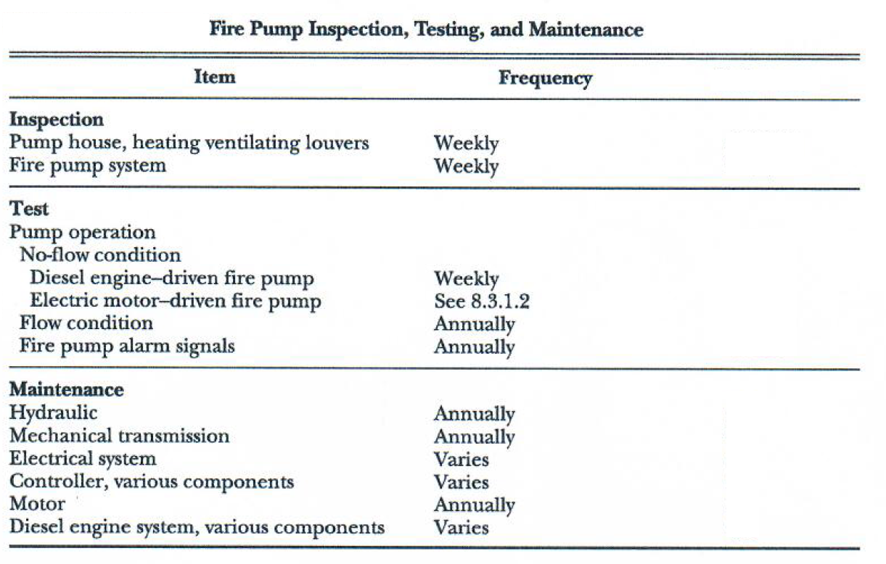

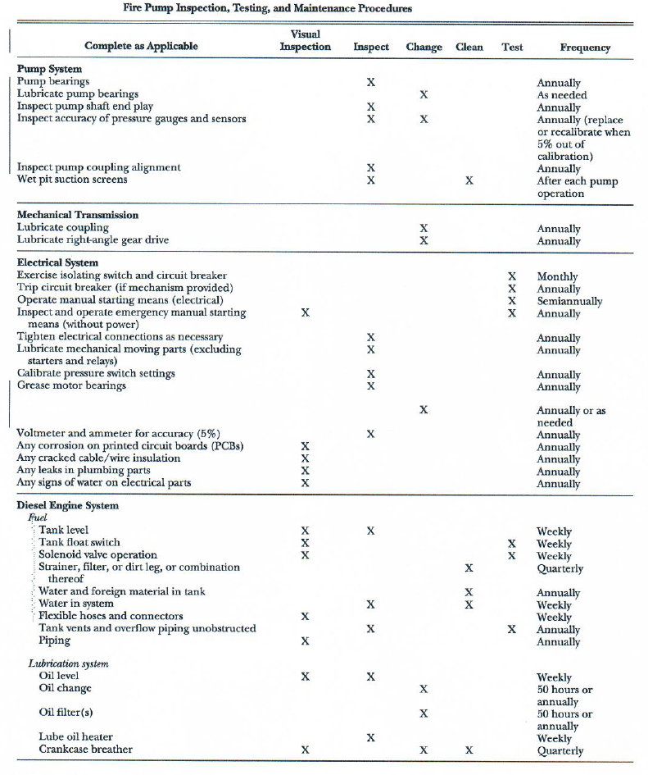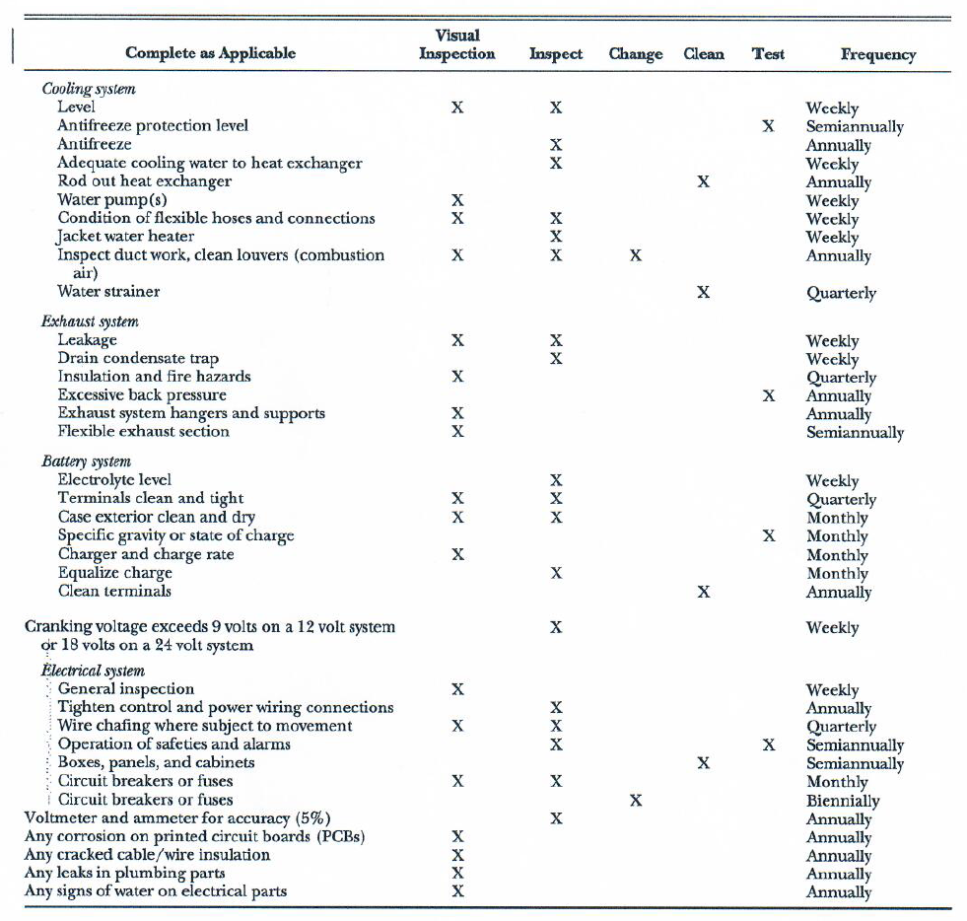

Appendix 7

# Daily Fire Inspection Checklist

|  |  |
| --- | --- |
| **Logo** | **DAILY FIRE INSPECTION CHECKLIST** |

|  |  |  |  |  |  |  |  |  |
| --- | --- | --- | --- | --- | --- | --- | --- | --- |
| Building: |  | | | | | Safety Officer: |  | |
| Area checked: |  | | | | | Date: |  | |
| **Item** | | **Y** | **N** | **NA** | **Summarize below any faults or concerns** | | | **Date rectified** |
| **Escape Routes**  ⁭  ⁭ | | | | | | | | |
| 1. Are emergency escape routes clear? (No stored equipment, furniture, etc). | | ⁭ | ⁭ |  |  | | |  |
| 2. Are emergency exit doors clear of obstructions? (not hidden by displays, posters, etc). | | ⁭ | ⁭ |  |  | | |  |
| 3. Can fire exits be easily and immediately opened? (Without use of key or similar). | |  |  |  |  | | |  |
| 4. Are external escape routes clear and safe? (well lit, clear of vehicles, etc). | |  |  |  |  | | |  |
| **Fire Notification Systems** | | | | | | | | |
| 5. Are manual call points clearly visible and not damaged? (Not hidden behind furniture, displays, etc). | | ⁭ | ⁭ |  |  | | |  |
| **Lighting – under construction** | | | | | | | |  |
| 7. Are emergency exit signs clear and conspicuous to all building users? | | ⁭ | ⁭ |  |  | | |  |
| 8. Are emergency exit routes adequately lit? | | ⁭ | ⁭ |  |  | | |  |
| **Fire Fighting Equipment** | | | | | | | |  |
| 9. Are fire extinguishers visible / easily accessible? (Not hidden or obstructed, etc). | | ⁭ | ⁭ |  |  | | |  |
| 10. Are fire extinguishers within their annual test period? (as per the attached label)? | | ⁭ | ⁭ |  |  | | |  |
| 11. Are fire hose reel cabinets, landing valves, breeching inlets clean, not leaking and cabinet contents available? | |  |  |  |  | | |  |
| **Fire Signs and Notices** | | | | | | | |  |
| 12. Do fire doors have the appropriate sign (e.g. ‘Fire Door, keep shut’)? | | ⁭ | ⁭ |  |  | | |  |
| 13. Are fire evacuation notices showing an appropriate fire assembly point? | | ⁭ | ⁭ |  |  | | |  |
| 14. is the fire action poster available and emergency contacts up to date? | |  |  |  |  | | |  |

Appendix 8

# Fire Extinguisher Monthly Inspection Register

|  |  |
| --- | --- |
| **Logo** | **Fire Extinguisher Monthly Inspection Register** |

|  |  |  |  |  |  |  |  |  |  |  |  |  |  |  |  |  |  |  |  |  |  |  |  |  |  |  |  |
| --- | --- | --- | --- | --- | --- | --- | --- | --- | --- | --- | --- | --- | --- | --- | --- | --- | --- | --- | --- | --- | --- | --- | --- | --- | --- | --- | --- |
|  |  | | |  | | | |  | |  | |  | |  | |  | |  | |  | | CO2 Type Extinguisher | | | | |  |
|  |  | | |  | | | |  | |  | |  | |  | |  | |  | |  | |  | |  | |  |  |
|  |  | | |  | | | |  | |  | |  | |  | |  | |  | |  | | 10 kgs. Dry Powdered Extinguisher | | | | | |
|  |  | | |  | | | |  | |  | |  | |  | |  | |  | |  | |  | |  | |  |  |
|  | | | | | | | | | | | | | | | | | | | | | | | | | | | |
| **Tag No.** | | **Location** | **Color Code** | | **Jan** | **Feb** | **March** | | **April** | | **May** | | **June** | | **July** | | **Aug** | | **Sep** | | **Oct** | | **Nov** | | **Dec** | **REMARKS** | |
|  | |  |  | |  |  |  | |  | |  | |  | |  | |  | |  | |  | |  | |  |  |  |
|  | |  |  | |  |  |  | |  | |  | |  | |  | |  | |  | |  | |  | |  |  |  |
|  | |  |  | |  |  |  | |  | |  | |  | |  | |  | |  | |  | |  | |  |  |  |
|  | |  |  | |  |  |  | |  | |  | |  | |  | |  | |  | |  | |  | |  |  |  |
|  | |  |  | |  |  |  | |  | |  | |  | |  | |  | |  | |  | |  | |  |  |  |
|  | |  |  | |  |  |  | |  | |  | |  | |  | |  | |  | |  | |  | |  |  |  |
|  | |  |  | |  |  |  | |  | |  | |  | |  | |  | |  | |  | |  | |  |  |  |
|  | |  |  | |  |  |  | |  | |  | |  | |  | |  | |  | |  | |  | |  |  |  |
|  | |  |  | |  |  |  | |  | |  | |  | |  | |  | |  | |  | |  | |  |  |  |
|  | |  |  | |  |  |  | |  | |  | |  | |  | |  | |  | |  | |  | |  |  |  |
| **Signature** | | | | |  |  |  | |  | |  | |  | |  | |  | |  | |  | |  | |  |  | |

Appendix 9

# Monthly Fire Alarm Test

|  |  |
| --- | --- |
| **Logo** | **MONTHLY FIRE ALARM TEST RECORD** |

|  |  |  |  |
| --- | --- | --- | --- |
| **2017** | **Actions taken/Remarks** | **Tested by** | **Signature** |
| January |  |  |  |
| February |  |  |  |
| March |  |  |  |
| April |  |  |  |
| May |  |  |  |
| June |  |  |  |
| July |  |  |  |
| August |  |  |  |
| September |  |  |  |
| October |  |  |  |
| November |  |  |  |
| December |  |  |  |

Appendix 10

# Emergency Contact Detail

|  |  |  |  |  |  |  |  |  |  |  |
| --- | --- | --- | --- | --- | --- | --- | --- | --- | --- | --- |
| **FIRE & EMERGENCY MANAGEMENT TEAM** | | | | | | | | | | |
| **AREA** | | **NAME** | **DESIGNATION** | **ROLE** | | **TRAINING** | **CONTACT NUMBERS** | **SUB-CONTRACTOR’S REPRESENTIVES** | | |
| **NAME** | **COMPANY** | **CONTACT NO.** |
| **ALL AREAS** | |  |  | **Sr. Emergency Controller** | |  |  |  |  |  |
|  |  | **Emergency Controller** | |  |  |  |  |  |
|  |  | **Emergency Controller** | |  |  |  |  |  |
|  |  | **Sr. Emergency Coordinator** | |  |  |  |  |  |
|  |  | **Emergency Coordinator** | |  |  |  |  |  |
|  |  | **Communication Officer** | |  |  |  |  |  |
|  |  | **Emergency Coordinator** | |  |  |  |  |  |
|  |  | **Communication Officer** | |  |  |  |  |  |
|  |  | **First Aider** | |  |  |  |  |  |
| **HOSPITAL AND AUTHORITY** |  | |  | |  | | **FIRE / CIVIL DEFENSE** | |  | |
|  | |  | |  | | **AMBULANCE** | |  | |
|  | |  | |  | | **POLICE** | |  | |

130

Appendix 11

# Fire Emergency Organisation

132

**FIRE INCIDENT ORGANISATION**

**Fire Wardens**

Project Senior HSE Manager (Fire Prevention Program Manager)

Security Guards

First Aiders

Receptionist

Emergency Coordinators

Appendix 12

# Emergency Drill Report

|  |  |
| --- | --- |
| **Logo** | **EMERGENCY DRILL REPORT** |

**Attach to this form a list of all staff who participated in the drill, and any visitors participating.**

|  |  |  |  |
| --- | --- | --- | --- |
| **Person Completing**  **Form Name and Title:** |  | **Date:** |  |

|  |  |  |
| --- | --- | --- |
| **Time Alarm Sounded:** | **Time Drill Concluded:** | **Time to Evacuate: (fire evacuation drills only)** |

|  |  |  |
| --- | --- | --- |
| **Type of Drill:** | **Notification / Alert Method:** | **Weather Conditions:** |
| * Fire / Evacuation * Chemical Spillage/Leak * Equipment Failure * Medical Emergency * Weather Emergency * Other:__________________ | * Hand Bell * Enhanced Alert System * Phone * Voice Notification * Siren * Other: _____________ | * Clear * Cloudy * Raining * Rain and wind * Windy * Foggy |
| **Participants:** (check all that apply) | **Situation at Start of Drill:** |  |
| * Senior Management * Safety Personnel * Employees/Staff * Security * Law Enforcement * Civil Defense * Emergency Medical Services * Other ___________________ | * Before Business Hours * During Business Hours * Peak Business Hours * Lunch Time * After Business Hours * Other: _______________ |  |
| **Management previously trained on emergency procedures this year?** | **Employees previously trained on emergency procedures this year?** |  |
| * Yes * No | * Yes * No |  |
| **Incident Command System Used?** | **Incident Commander:** | **Manager:** |
| * Yes * No |  |  |

|  |  |
| --- | --- |
| **Problems Encountered:** (Check all that apply) |  |
| * Congestion in hallways * Alarm not heard * Employees unsure of what to do / proper * Staff unsure of responsibilities / response * Weather-related problems * Unable to lock doors * Windows not covered * Windows left open * Doors left open * Lights left on * Personnel not accounted for / attendance * Personnel unaccounted for (note # below) | * Network / computer problems * Noise impedes communications * Long time to evacuate building * Personnel not serious about drill * Improper or unavailable supplies * Confusion * Doors or Exits blocked * Transportation * Interagency miscommunications * Incident command problems * Other: ____________________________ __________________________________ |
| **Extenuating Circumstances / Identified Factors / Special Conditions Simulated:** | |

|  |  |  |  |  |  |
| --- | --- | --- | --- | --- | --- |
| **Mitigation / Plans for Improvement:** (check all that apply and explain below) | | | | | |
| * Additional management training * Additional staff training * Address need for additional equipment * Improved emergency supplies | | | * Cooperative planning with responders * Revised emergency procedures * Other: | | |
| **Corrective Actions Required** | | | | | |
| **Serial No.** | **Action** | **By who** | | **By Date** | **Status** |
|  |  |  | |  |  |
|  |  |  | |  |  |
|  |  |  | |  |  |
|  |  |  | |  |  |

|  |  |
| --- | --- |
| **Signatures:** | |
| Position: | Position: |

Appendix 12

# Drawings

**LAST PAGE**

Get more QHSE plans, procedures, files, documents, and training presentations.

fjcabagte@gmail.com

+639950276663 | WhatsApp